GALA ‘HOW TO’ GUIDE
GETTING STARTED
Q - When can my child start to compete?
A – We encourage swimmers to enter the Internal Club Galas as soon as they join the club. Coaches do not put you forward – it’s up to you to enter. These are very relaxed, friendly and sociable galas held on Thursday club night 7 times per year. See page 2 for details.

Q - What about External Galas?
A – If you’re in group 4 – 6, or new to Yorkshire Development Group, you can enter the District Galas. The Kirklees and District galas are held at Huddersfield Sports Centre on a Sunday afternoon.

Q – What other galas do Halifax swimmers attend?
A – Swimmers in Yorkshire and Regional Development groups are required to compete in graded galas and open meets (see page 3). These are outlined on the club’s gala calendar, which is issued at the beginning of every season.

JARGON BUSTER
SWIM ENGLAND – Swim England. This is the governing body of our sport in the UK. For times to count, the meet must have an SWIM ENGLAND license.
PB – Personal Best – i.e. the fastest time a swimmer has ever achieved in an event. This is what every swimmer should aim to achieve.
SHORT COURSE – 25m pool. Times are slightly faster in a 25m pool, because the swimmer has the advantage of making more tumble turns in a race. This creates momentum off the wall. Halifax is a 25m pool.

LONG COURSE – 50M pool. Halifax competes in several long-course meets throughout the season.

SWIM ENGLAND Category 2 Membership – Required for all swimmers in Yorkshire and Regional Development Groups. Without it, swimmers cannot compete in Level 3 and above meets (see Graded Meets on page 3). This is an annual fee (£26.75).

COMPETITIVE START AWARD – Needed to dive into shallow water. This is for your safety. Ask your coach about achieving this award. Certificates are available from Mary.

INTERNAL CLUB GALAS
Open to: All club members.
Bronze, Silver, Gold & Platinum groups
Most likely, you’ll start in Bronze group. As you achieve times set out by the SWIM ENGLAND, you’ll progress to to Silver Group, then Gold and Platinum.

Medals are won based on points. The points are earned based on time improvements. Except for 25m events, times achieved go into the British rankings and can be used as qualifying times for higher-level meets.

The cost to enter is £2 per gala (or £10 for the full year). There is a small charge for spectators and a raffle on the night.
Which events?
You’ll find the events and entry deadlines for each gala on our website: www.halifaxswimmingclub.co.uk/galas/internal-galas.

The entry secretary for Internal Club Galas is Amanda Raine. She can be found in the first block of seats in the spectator gallery on most club nights and will be happy to help with any questions. For swimmers who’ve already paid, entries can also be made via email to araine492@gmail.com.

DISTRICT GALAS
Open to: Groups 4—6 aged 9 years +. Also open to swimmers new to Yorkshire Development, whose only competition experience is internal galas.

Kirklees & District galas are run in a series of 5 galas between September and May/June with the final gala in each series being a team gala with relays.
You’ll have a good choice of events, and don’t need qualifying times to enter. The times you achieve will not be official times, so you can’t use them as qualifying times for other meets. But that’s not the point -- these galas are fantastic for honing your skills and gaining some competitive experience, with a chance to pick up medals and trophies.
Parents are invited to attend and support the swimmers. The galas are friendly and informal with a great atmosphere.
Where?
The Kirklees and District galas are held at the new Huddersfield Sports Centre on a Sunday afternoon.
Details of the galas, once confirmed, will be posted on the notice board in the spectator’s gallery or at www.halifaxswimmingclub.co.uk/galas/external-galas (bottom of the page)
The entry secretary for District Galas is Jackie Collett. She can be found in the spectator gallery on most club nights and will be happy to help with any questions.

GRADED GALAS AND OPEN MEETS
Open to: Yorkshire Development, Regional Development Groups
Note: Some galas are open to group 6 swimmers
A calendar of suggested and mandatory galas is issued to all swimmers in YD and RD groups at the beginning of each season. You can also find it on the website.
By joining YD or RD groups swimmers have indicated that they want to compete. They must swim a suitable number of meets as shown on the gala calendar.
To compete in any graded or open meet you will need:
- SWIM ENGLAND Category 2 membership (page 1, JARGON BUSTER)
- Qualifying times. All meets vary on this. This means that your times must meet the standards set by the meet organiser.

What are graded meets?
Graded meets denote time standards. They’re geared towards swimmers whose times are within that grade. For some meets, you’ll hear the phrase ‘A & B Grade’. B grade means good club standard. A grade times are faster and usually qualify you for county championships.

What do levels mean?
Another indication of the time standards. Levels range from Level 1 (fastest) to Level 4, which are generally designed for developing swimmers.

Level 4: These low-level meets usually don’t require qualifying times. Our own in-house galas are Level 4s. Swimmers can achieve qualifying times to enter graded meets and some open meets.

Level 3: Faster qualifying times and a higher standard of swimming than Level 4. Graded meets are almost always Level 3s. These take place in both short- and long-course pools.

Level 2: Faster qualifying times than Level 3. Times achieved here can qualify you for most meets. Level 2s are short course.

Level 1: These are the meets with the fastest qualifying times and highest standards of swimming. Level 1s are long course.

What events can I qualify for?
That depends on the meet and the event. All meets have qualifying times, and you enter with your PBs (personal best times). Qualifying times vary according to the meet’s level and grade. Using the example below, you have ‘slower than’ times. So if you’re faster than the cut-off times, this isn’t the meet for you.

Upper Permitted Times - Short Course 25m Pool
Your Personal Best time must be SLOWER than these times to enter this meet.
GIRLS
EVENT |  | 9 | 10 | 11 | 12 | 13 | 14 | 15 & Over
50m | Freestyle | 43.9 | 40.3 | 38.0 | 36.0 | 34.4 | 33.4 | 32.6
100m | Freestyle |  | 1:28.5 | 1:22.0 | 1:17.2 | 1:13.9 | 1:11.6 | 1:10.2
200m | Freestyle |  |  | 3.06.8 | 2:56.1 | 2.38.8 | 2:34.1 | 2:30.8
50m | Breaststroke | 56.5 | 52.2 | 48.6 | 45.7 | 43.5 | 42.0 | 40.9
100m | Breaststroke |  | 1:53.8 | 1:44.3 | 1:37.9 | 1:32.8 | 1:29.1 | 1:27.5
50m | Butterfly | 48.5 | 44.3 | 41.7 | 39.3 | 38.3 | 36.2 | 35.3
100m | Butterfly |  | 1:40.2 | 1:31.5 | 1:25.5 | 1:21.6 | 1:18.5 | 1:17.2
50m | Backstroke | 49.4 | 45.8 | 43.1 | 40.8 | 38.9 | 37.6 | 36.9
100m | Backstroke |  | 1:39.5 | 1:31.7 | 1:25.8 | 1:21.8 | 1:19.3 | 1:17.4
100m | Ind.Medley | 1:49.1 | 1:40.2
200m | Ind. Medley |  |  | 3:19.7 | 3:07.4 | 2:59.5 | 2:53.8 | 2:50.4

Some meets have ‘must be faster than’ times. It all depends on the meet.

Where do I find my times?
You should keep a record of your times on Swim Club Manager. (When you joined, you were given the information to set up your SCM page.) You can also find them on the SWIM ENGLAND website. Google SWIM ENGLAND biogs or type this into your browser: https://www.swimmingresults.org/biogs/ and go from there.

How to enter: Long course times vs. short course times
Always use your PB, or fastest time. Generally, swimmers’ times are faster in short course pools, as they have more turns. That’s because pushing off the wall creates more momentum. But the time you enter depends on whether or not the pool is long or short course.

Let’s say this swimmer wants to swim the 50 free at a short course meet. This is pretty straight forward. Her short course time is faster than her long course time, so she’ll enter 35.98.
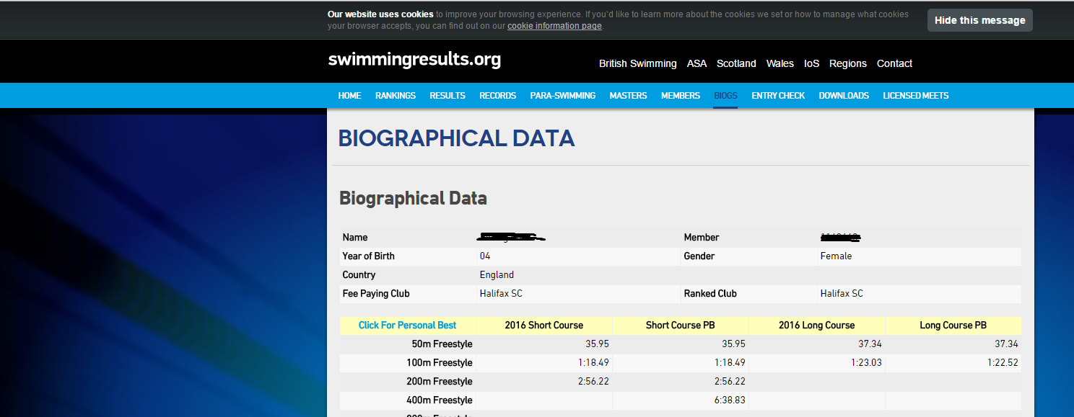

Let’s flip the scenario. Say the swimmer below wants to enter a short course meet and swim the 100m free. His long course time of 1:01.42 is actually faster than his short course time of 1:02.76.
To arrive at his short course PB, he needs to convert his long course time to short course. Using an online conversion calculator, his PB for short course comes out to 1:00.00. That’s the time he uses to enter.
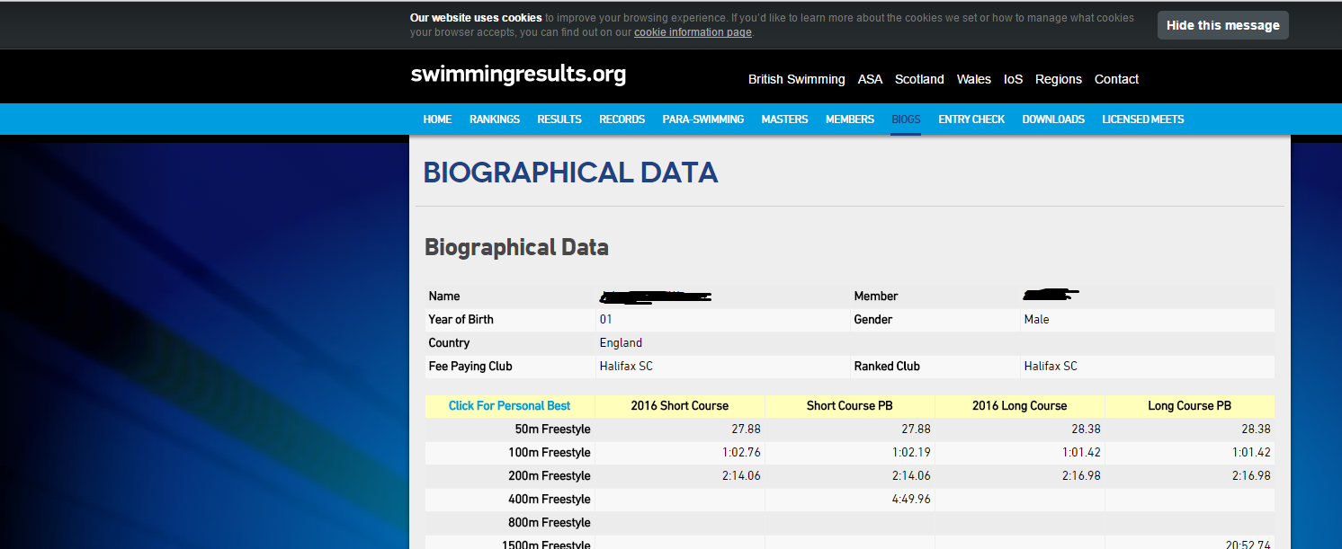

Where to I find a conversion calculator?
This link is on the Galas > External Galas page:
http://swimcalc.com/swimcalc.php/convert

Another good one can be found here:
http://www.pullbuoy.co.uk/times

I’m entering a long course meet but only have short course times
You convert your times so that they’re the equivalent of long-course times, like this example:

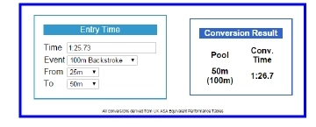

OFFICIAL TIMES
At Galas that meet specific criteria from the SWIM ENGLAND, swimmers will be able to achieve official times that are entered on to the SWIM ENGLAND rankings.
You will be able to view your swimmer’s times on
www.swimmingresults.org/individualbest or www.swimmingresults.org/biogs
Search using family name or SWIM ENGLAND number from your SWIM ENGLAND Category 2 Membership card (see page 1 – JARGON BUSTER)
These are the only times you can use as qualifying times to enter galas. They are only valid for 12 months.
NB – The above website will clearly show if a time was achieved in a Long Course or a short course event. (see page 1 – JARGON BUSTER)
ALWAYS USE YOUR SWIMMERS FASTEST TIME. YOU CAN NEARLY ALWAYS ENTER A SHORT COURSE EVENT WITH A LONG COURSE TIME OR VICE VERSA, BUT YOU WILL NEED TO CONVERT THE TIME.
To convert a time from long course to short OR from short course to long use either of the following
www.swimcalc.com/cgi-bin/convert.cgi/default
www.pullbuoy.co.uk/times
To enter graded meets and many open meets your swimmer must meet certain criteria regarding entry times. Very often entry requires that your time is faster than the ‘NOT SLOWER THAN’ time and slower than the ‘NOT FASTER THAN’. These may be referred to as UPPER AND LOWER CUT OFF TIMES. If you see these criteria for a gala it will be clearly shown on the entry details posted on the website at www.halifaxswimmingclub.co.uk/galas/external-galas. Note there will be different times for each age group and for Boys and Girls.
WHEN ENTRIES ARE SUBMITTED THEY WILL BE CHECKED AGAINST THE SWIMMERS TIMES POSTED ON THE SWIM ENGLAND RANKINGS so there is no point in trying to enter swimmers whose times do not meet the criteria. The entry will be automatically rejected.
If the swimmer swims faster than the ‘NO FASTER THAN’ time at the gala itself, that’s not problem at all. In fact great news, a PB to be celebrated! Your swimmer will be issued with a SPEEDING TICKET to treasure along with their medals.
HOW TO ENTER
Details of all galas that Halifax club have agreed to enter are listed at
www.halifaxswimmingclub.co.uk/galas/external-galas
As meet details become available, they’ll appear on that page. There will also be a Halifax entry form for each event. Please use this form to complete your entry and pass to the entry secretary. They will collate the entry from all Halifax swimmers and submit the entries as one, usually electronically.
It’s important to note the entry deadline on the Halifax entry form. This will be earlier than the deadline for the meet itself to allow time for the entry secretary to check and compile all the entries for the club – and to get the entries in with time to spare. It’s common for meets to close early due to filling up so quickly. (We have been shut out of meets before.)
- Check if the meet is long course or short course – make sure your entry times are the correct format and convert them if not. Make sure you use your swimmers fastest official time wherever it was achieved.
- Check what date is used for the AGE. Most galas now follow SWIM ENGLAND guidelines and use age at 31st December, however some will still operate on AGE ON DATE. It is important to check you are entering your swimmer in the correct age group.
- Check HIGHER AND LOWER CUT OFF TIMES (see Official times – page 4) and only enter for events where your swimmer fits the criteria.
- Carefully check you have entered all the events you need. You will not be able to add events after the closing date.
- Check you have included the correct payment, or if paying on line that you have used the reference detailed on the entry form.
- If you are not sure about anything – Ask. Better to check in advance than have your entry rejected due to errors.
Nearer the time of the event the gala secretary will email full detail of the event including often a draft programme to check, warm up times and details of team managers who will be looking after swimmers on poolside along with emergency contact numbers.

KEEPING UP TO DATE
To make sure you keep up to date events we are attending and news and links to live results regularly check www.halifaxswimmingclub.co.uk or follow us on Twitter @Halifaxsclub or on Facebook HalifaxSC

